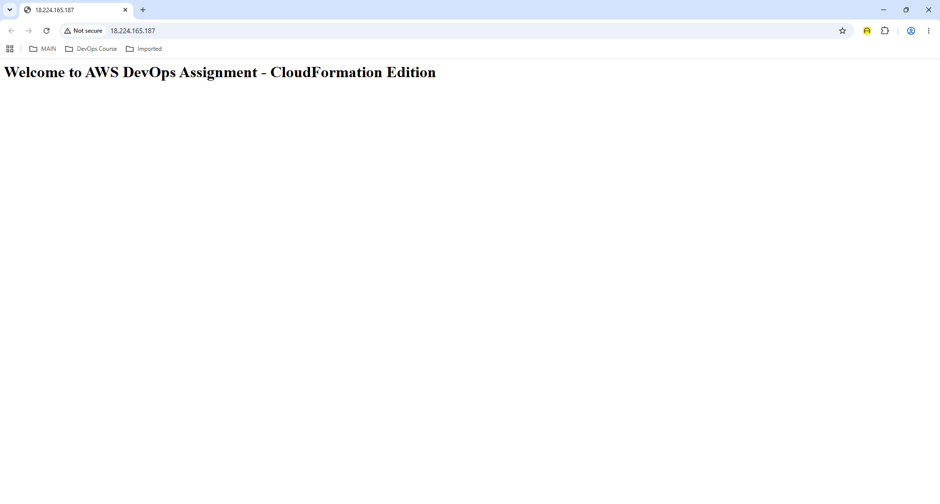

PS C:\Users\den\Projects\aws-devops-assignment> aws cloudformation describe-stacks --stack-name devops-assignment-stack --query "Stacks[0].Outputs" --output json
[
{
"OutputKey": "WebsiteURL",
"OutputValue": "http://18.224.165.187",
"Description": "Public URL for the EC2 web server"
},
{
"OutputKey": "S3BucketName",
"OutputValue": "aws-devops-assignment-cf-631237958452",
"Description": "Created S3 Bucket Name"
}
]

PS C:\Users\den\Projects\aws-devops-assignment>

PS C:\Users\den\Projects\aws-devops-assignment> aws cloudformation validate-template --template-body file://cloudformation/infrastructure.yaml
{
"Parameters": [
{
"ParameterKey": "EnvironmentName",
"DefaultValue": "dev",
"NoEcho": false,
"Description": "Environment name for tagging"
}
],
"Description": "AWS DevOps Assignment - CloudFormation Infrastructure Stack - Updated"
}

PS C:\Users\den\Projects\aws-devops-assignment> aws cloudformation describe-stacks --stack-name devops-assignment-stack --query "Stacks[0].StackStatus"
"UPDATE_COMPLETE"

PS C:\Users\den\Projects\aws-devops-assignment> aws cloudformation describe-stacks --stack-name devops-assignment-stack --query "Stacks[0].StackStatus"
"UPDATE_COMPLETE"

PS C:\Users\den\Projects\aws-devops-assignment> aws cloudformation describe-stacks --stack-name devops-assignment-stack --query "Stacks[0].Outputs" --output json
[
{
"OutputKey": "WebsiteURL",
"OutputValue": "http://18.217.161.168",
"Description": "Public URL for the EC2 web server"
},
{
"OutputKey": "S3BucketName",
"OutputValue": "aws-devops-assignment-cf-631237958452",
"Description": "Created S3 Bucket Name"
}
]

PS C:\Users\den\Projects\aws-devops-assignment>

AWSTemplateFormatVersion: '2010-09-09'
Description: "AWS DevOps Assignment - CloudFormation Infrastructure Stack - Updated"

Parameters:
EnvironmentName:
Type: String
Default: 'dev'
Description: 'Environment name for tagging'

Resources:
# 1. Virtual Private Cloud (VPC)
MyVPC:
Type: AWS::EC2::VPC
Properties:
CidrBlock: 10.0.0.0/16
EnableDnsHostnames: true
EnableDnsSupport: true
Tags:
- Key: Name
Value: !Sub '${EnvironmentName}-vpc'
- Key: Owner
Value: 'den'
- Key: Project
Value: 'aws-devops-assignment'
- Key: Environment
Value: !Ref EnvironmentName

# 2. Subnet
MySubnet:
Type: AWS::EC2::Subnet
Properties:
VpcId: !Ref MyVPC
CidrBlock: 10.0.1.0/24
MapPublicIpOnLaunch: true
Tags:
- Key: Name
Value: !Sub '${EnvironmentName}-subnet'
- Key: Owner
Value: 'den'
- Key: Project
Value: 'aws-devops-assignment'
- Key: Environment
Value: !Ref EnvironmentName

# Internet Gateway & Route Table (Required for public EC2 connectivity)
InternetGateway:
Type: AWS::EC2::InternetGateway
Properties:
Tags:
- Key: Name
Value: !Sub '${EnvironmentName}-igw'

GatewayAttachment:
Type: AWS::EC2::VPCGatewayAttachment
Properties:
VpcId: !Ref MyVPC
InternetGatewayId: !Ref InternetGateway

PublicRouteTable:
Type: AWS::EC2::RouteTable
Properties:
VpcId: !Ref MyVPC

PublicRoute:
Type: AWS::EC2::Route
DependsOn: GatewayAttachment
Properties:
RouteTableId: !Ref PublicRouteTable
DestinationCidrBlock: 0.0.0.0/0
GatewayId: !Ref InternetGateway

SubnetRouteTableAssociation:
Type: AWS::EC2::SubnetRouteTableAssociation
Properties:
SubnetId: !Ref MySubnet
RouteTableId: !Ref PublicRouteTable

# 3. Security Group
WebServerSecurityGroup:
Type: AWS::EC2::SecurityGroup
Properties:
GroupDescription: Enable HTTP and SSH access
VpcId: !Ref MyVPC
SecurityGroupIngress:
- IpProtocol: tcp
FromPort: 80
ToPort: 80
CidrIp: 0.0.0.0/0
Description: Allow HTTP traffic
- IpProtocol: tcp
FromPort: 22
ToPort: 22
CidrIp: 0.0.0.0/0
Description: Allow SSH access (restrict in production)
Tags:
- Key: Name
Value: !Sub '${EnvironmentName}-sg'
- Key: Owner
Value: 'den'
- Key: Project
Value: 'aws-devops-assignment'

# 4. S3 Bucket
MyS3Bucket:
Type: AWS::S3::Bucket
Properties:
BucketName: !Sub 'aws-devops-assignment-cf-${AWS::AccountId}'
VersioningConfiguration:
Status: Enabled
Tags:
- Key: Owner
Value: 'den'
- Key: Project
Value: 'aws-devops-assignment'
- Key: Environment
Value: !Ref EnvironmentName

# 5. EC2 Instance
WebServerInstance:
Type: AWS::EC2::Instance
Properties:
ImageId: ami-0c55b159cbfafe1f0 # Amazon Linux 2023 AMI for us-east-2
InstanceType: t3.micro
SubnetId: !Ref MySubnet
SecurityGroupIds:
- !Ref WebServerSecurityGroup
UserData:
Fn::Base64: !Sub |
#!/bin/bash
yum update -y
yum install -y httpd
systemctl start httpd
systemctl enable httpd
echo "<h1>Welcome to AWS DevOps Assignment - CloudFormation Edition</h1>" > /var/www/html/index.html
Tags:
- Key: Name
Value: !Sub '${EnvironmentName}-web-server'
- Key: Owner
Value: 'den'
- Key: Project
Value: 'aws-devops-assignment'

Outputs:
WebsiteURL:
Description: Public URL for the EC2 web server
Value: !Sub 'http://${WebServerInstance.PublicIp}'
S3BucketName:
Description: Created S3 Bucket Name
Value: !Ref MyS3Bucket

